|  | Loan_ID | Gender | Married | Dependents | Education | Self_Employed | ApplicantIncome | CoapplicantIncome | LoanAmount | Loan_Amount_Term | Credit_History | Property_Area | Loan_Status |
| --- | --- | --- | --- | --- | --- | --- | --- | --- | --- | --- | --- | --- | --- |
| 0 | LP001002 | Male | No | 0 | Graduate | No | 5849 | 0.0 | NaN | 360.0 | 1.0 | Urban | Y |
| 1 | LP001003 | Male | Yes | 1 | Graduate | No | 4583 | 1508.0 | 128.0 | 360.0 | 1.0 | Rural | N |
| 2 | LP001005 | Male | Yes | 0 | Graduate | Yes | 3000 | 0.0 | 66.0 | 360.0 | 1.0 | Urban | Y |
| 3 | LP001006 | Male | Yes | 0 | Not Graduate | No | 2583 | 2358.0 | 120.0 | 360.0 | 1.0 | Urban | Y |
| 4 | LP001008 | Male | No | 0 | Graduate | No | 6000 | 0.0 | 141.0 | 360.0 | 1.0 | Urban | Y |
| 5 | LP001011 | Male | Yes | 2 | Graduate | Yes | 5417 | 4196.0 | 267.0 | 360.0 | 1.0 | Urban | Y |
| 6 | LP001013 | Male | Yes | 0 | Not Graduate | No | 2333 | 1516.0 | 95.0 | 360.0 | 1.0 | Urban | Y |
| 7 | LP001014 | Male | Yes | 3+ | Graduate | No | 3036 | 2504.0 | 158.0 | 360.0 | 0.0 | Semiurban | N |
| 8 | LP001018 | Male | Yes | 2 | Graduate | No | 4006 | 1526.0 | 168.0 | 360.0 | 1.0 | Urban | Y |
| 9 | LP001020 | Male | Yes | 1 | Graduate | No | 12841 | 10968.0 | 349.0 | 360.0 | 1.0 | Semiurban | N |

<class 'pandas.core.frame.DataFrame'>

RangeIndex: 614 entries, 0 to 613

Data columns (total 13 columns):

# Column Non-Null Count Dtype

--- ------ -------------- -----

0 Loan_ID 614 non-null object

1 Gender 601 non-null object

2 Married 611 non-null object

3 Dependents 599 non-null object

4 Education 614 non-null object

5 Self_Employed 582 non-null object

6 ApplicantIncome 614 non-null int64

7 CoapplicantIncome 614 non-null float64

8 LoanAmount 592 non-null float64

9 Loan_Amount_Term 600 non-null float64

10 Credit_History 564 non-null float64

11 Property_Area 614 non-null object

12 Loan_Status 614 non-null object

dtypes: float64(4), int64(1), object(8)

memory usage: 62.5+ KB

Gender Mode: 0 Male

Name: Gender, dtype: object

Married Mode: 0 Yes

Name: Married, dtype: object

Self_Employed Mode: 0 No

Name: Self_Employed, dtype: object

Credit_History Mode: 0 1.0

Name: Credit_History, dtype: float64

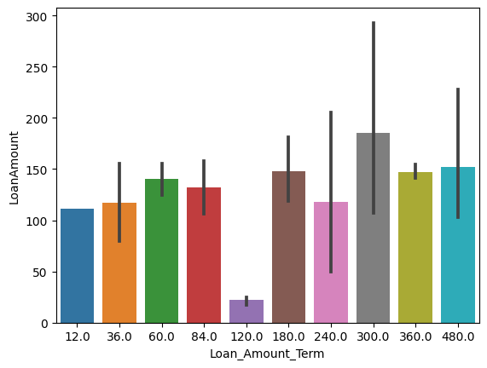

Loan_Amount_TermLoanAmount19NaN115.036NaN100.044NaN96.045NaN88.073NaN95.0112NaN152.0165NaN182.0197NaN120.0223NaN175.0232NaN120.0335NaN70.0367NaN124.0421NaN80.0423NaN110.0

0 345 1 102 2 101 3+ 51 Name: Dependents, dtype: int64

0 345 1 102 2 101 3 51 Name: Dependents, dtype: int64

|  | **Dependents** | **Married** |
| --- | --- | --- |
| **102** | NaN | Yes |
| **104** | NaN | NaN |
| **120** | NaN | Yes |
| **226** | NaN | Yes |
| **228** | NaN | NaN |
| **293** | NaN | No |
| **301** | NaN | Yes |
| **332** | NaN | No |
| **335** | NaN | Yes |
| **346** | NaN | Yes |
| **355** | NaN | No |
| **435** | NaN | NaN |
| **517** | NaN | Yes |
| **571** | NaN | Yes |
| **597** | NaN | No |

dtype('int64')

Loan_ID 0 Gender 0 Married 0 Dependents 0 Education 0 Self_Employed 0 ApplicantIncome 0 CoapplicantIncome 0 LoanAmount 0 Loan_Amount_Term 0 Credit_History 0 Property_Area 0 Loan_Status 0 dtype: int64

Gender 2 Married 2 Dependents 4 Education 2 Self_Employed 2 ApplicantIncome 505 CoapplicantIncome 287 LoanAmount 204 Loan_Amount_Term 11 Credit_History 3 Property_Area 3 Loan_Status 2 dtype: int64

Dependents ApplicantIncome CoapplicantIncome LoanAmount

count 614.000000 614.000000 614.000000 614.000000

mean 0.744300 5403.459283 1621.245798 146.412162

std 1.009623 6109.041673 2926.248369 84.037468

min 0.000000 150.000000 0.000000 9.000000

25% 0.000000 2877.500000 0.000000 100.250000

50% 0.000000 3812.500000 1188.500000 129.000000

75% 1.000000 5795.000000 2297.250000 164.750000

max 3.000000 81000.000000 41667.000000 700.000000

<Figure size 1000x400 with 0 Axes>

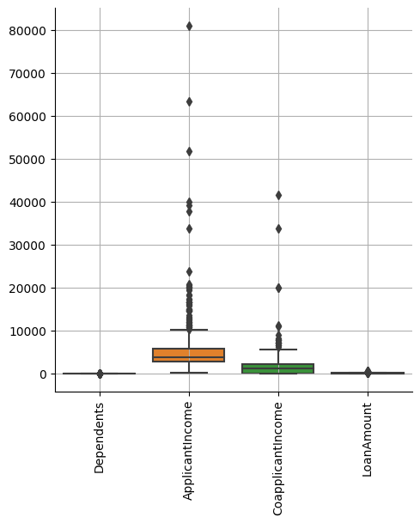

<Axes: xlabel='Education', ylabel='count'>

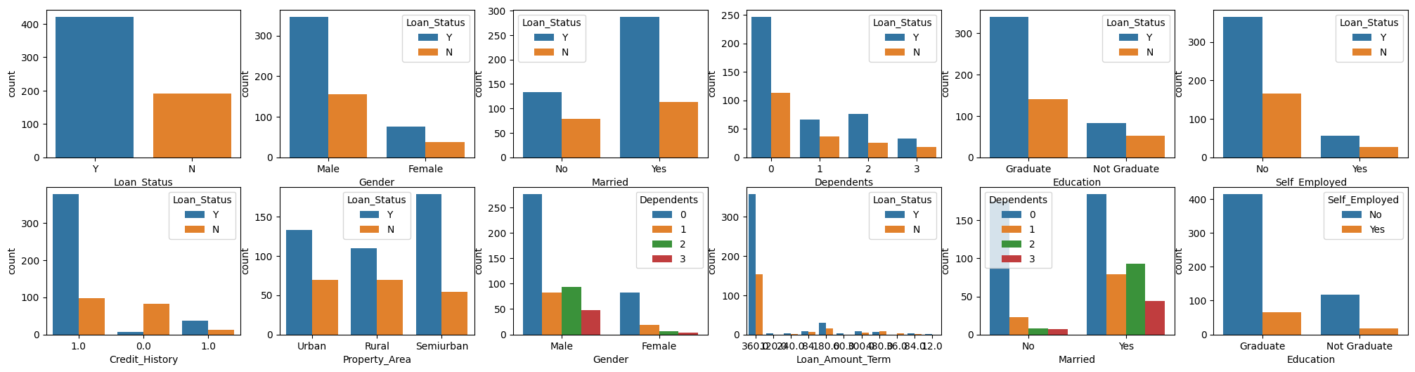

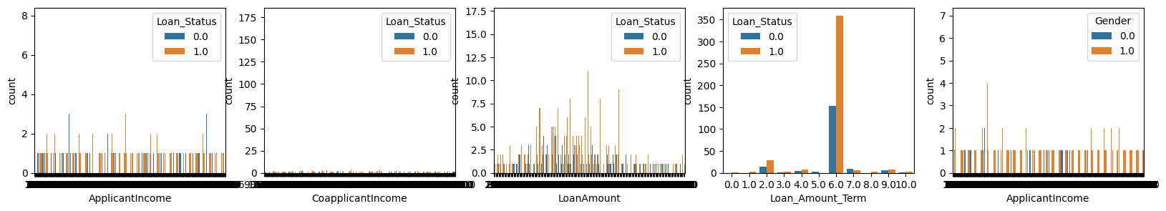

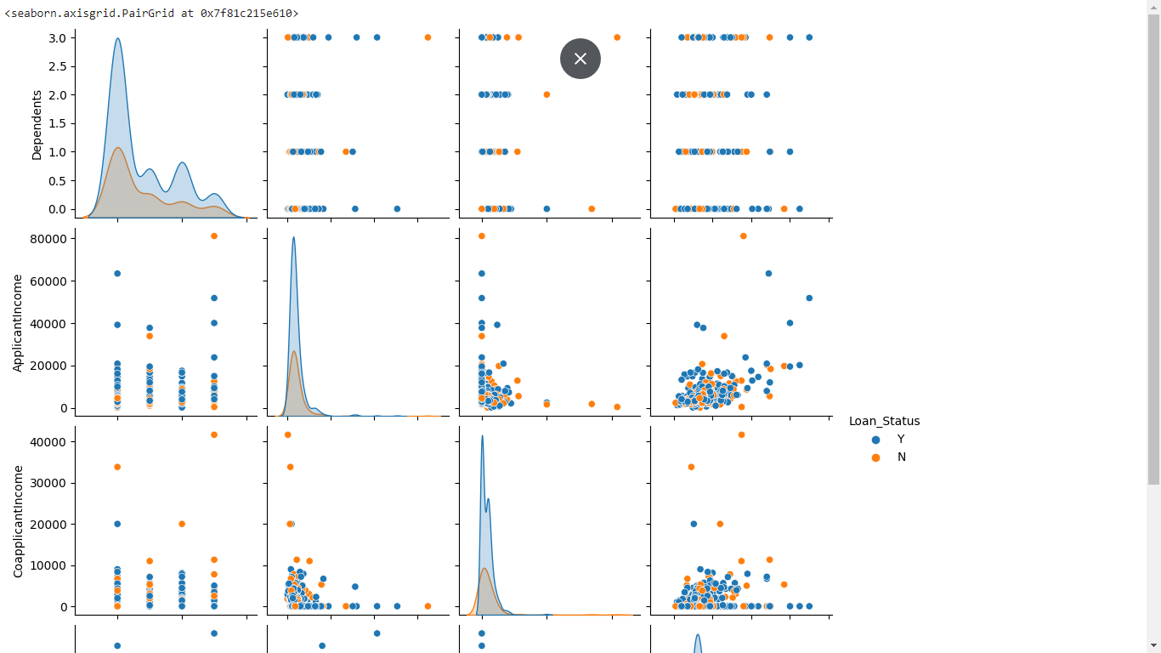

Index(['Gender', 'Married', 'Education', 'Self_Employed', 'Loan_Amount_Term', 'Credit_History', 'Property_Area', 'Loan_Status'], dtype='object')

Gender Married Dependents Education Self_Employed ApplicantIncome CoapplicantIncome LoanAmount Loan_Amount_Term Credit_History Property_Area Loan_Status

0 1.0 0.0 0 0.0 0.0 5849 0.0 146.412162 6.0 1.0 2.0 1.0

1 1.0 1.0 1 0.0 0.0 4583 1508.0 128.000000 6.0 1.0 0.0 0.0

2 1.0 1.0 0 0.0 1.0 3000 0.0 66.000000 6.0 1.0 2.0 1.0

plt.xticks(rotation = 90)

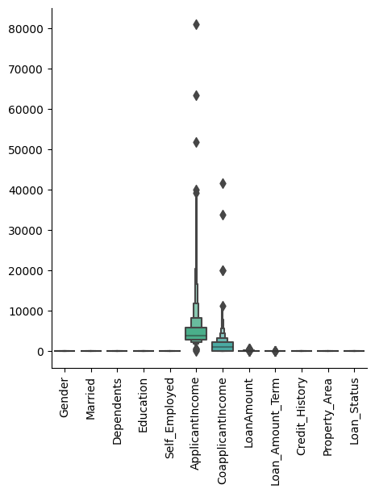

]

|  | **Gender** | **Married** | **Dependents** | **Education** | **Self_Employed** | **ApplicantIncome** | **CoapplicantIncome** | **LoanAmount** | **Loan_Amount_Term** | **Credit_History** | **Property_Area** | **Loan_Status** |
| --- | --- | --- | --- | --- | --- | --- | --- | --- | --- | --- | --- | --- |
| **count** | 614.000000 | 614.000000 | 614.000000 | 614.000000 | 614.000000 | 614.000000 | 614.000000 | 614.000000 | 614.000000 | 614.000000 | 614.000000 | 614.000000 |
| **mean** | 0.817590 | 0.653094 | 0.744300 | 0.218241 | 0.133550 | 5403.459283 | 1621.245798 | 146.412162 | 5.739414 | 0.855049 | 1.037459 | 0.687296 |
| **std** | 0.386497 | 0.476373 | 1.009623 | 0.413389 | 0.340446 | 6109.041673 | 2926.248369 | 84.037468 | 1.325067 | 0.352339 | 0.787482 | 0.463973 |
| **min** | 0.000000 | 0.000000 | 0.000000 | 0.000000 | 0.000000 | 150.000000 | 0.000000 | 9.000000 | 0.000000 | 0.000000 | 0.000000 | 0.000000 |
| **25%** | 1.000000 | 0.000000 | 0.000000 | 0.000000 | 0.000000 | 2877.500000 | 0.000000 | 100.250000 | 6.000000 | 1.000000 | 0.000000 | 0.000000 |
| **50%** | 1.000000 | 1.000000 | 0.000000 | 0.000000 | 0.000000 | 3812.500000 | 1188.500000 | 129.000000 | 6.000000 | 1.000000 | 1.000000 | 1.000000 |
| **75%** | 1.000000 | 1.000000 | 1.000000 | 0.000000 | 0.000000 | 5795.000000 | 2297.250000 | 164.750000 | 6.000000 | 1.000000 | 2.000000 | 1.000000 |
| **max** | 1.000000 | 1.000000 | 3.000000 | 1.000000 | 1.000000 | 81000.000000 | 41667.000000 | 700.000000 | 10.000000 | 1.000000 | 2.000000 | 1.000000 |

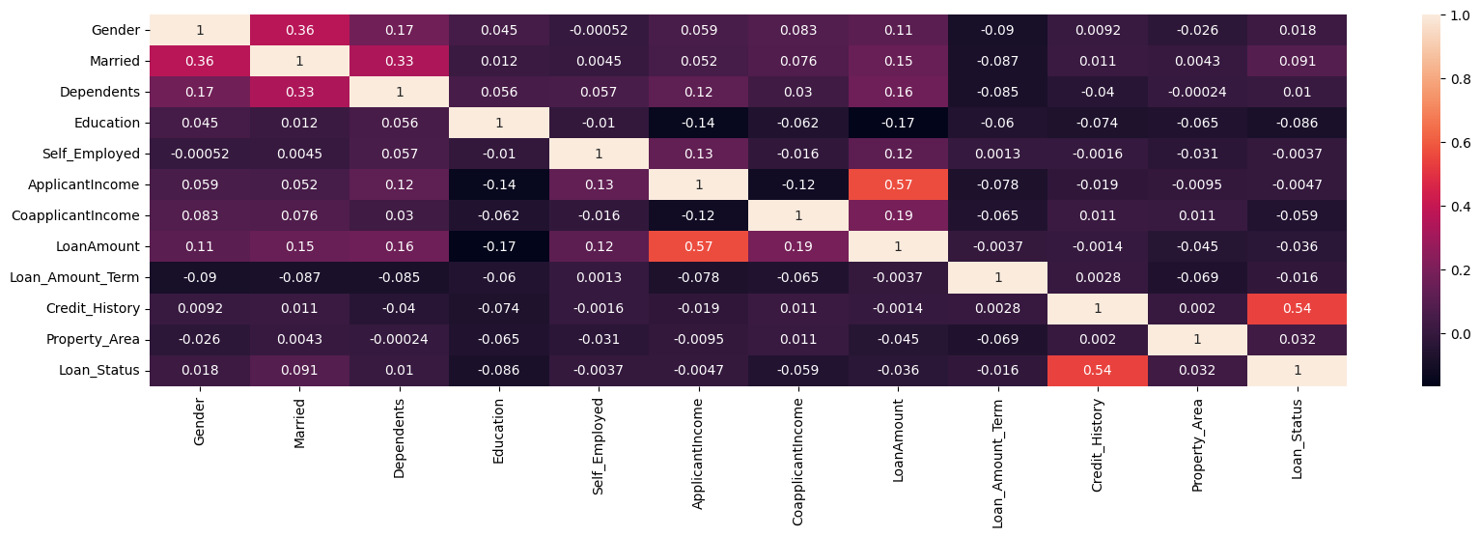

Gender Married Dependents Education Self_Employed ApplicantIncome CoapplicantIncome LoanAmount Loan_Amount_Term Credit_History Property_Area Loan_Status

0 0.472343 -1.372089 -0.737806 -0.528362 -0.392601 0.072991 -0.554487 0.000000 0.196819 0.411733 1.223298 1.0

1 0.472343 0.728816 0.253470 -0.528362 -0.392601 -0.134412 -0.038732 -0.219273 0.196819 0.411733 -1.318513 0.0

2 0.472343 0.728816 -0.737806 -0.528362 2.547117 -0.393747 -0.554487 -0.957641 0.196819 0.411733 1.223298 1.0

3 0.472343 0.728816 -0.737806 1.892641 -0.392601 -0.462062 0.251980 -0.314547 0.196819 0.411733 1.223298 1.0

4 0.472343 -1.372089 -0.737806 -0.528362 -0.392601 0.097728 -0.554487 -0.064454 0.196819 0.411733 1.223298 1.0

|  | **Gender** | **Married** | **Dependents** | **Education** | **Self_Employed** | **ApplicantIncome** | **CoapplicantIncome** | **LoanAmount** | **Loan_Amount_Term** | **Credit_History** | **Property_Area** |
| --- | --- | --- | --- | --- | --- | --- | --- | --- | --- | --- | --- |
| **0** | 0.472343 | -1.372089 | -0.737806 | -0.528362 | -0.392601 | 0.072991 | -0.554487 | 0.000000 | 0.196819 | 0.411733 | 1.223298 |
| **1** | 0.472343 | 0.728816 | 0.253470 | -0.528362 | -0.392601 | -0.134412 | -0.038732 | -0.219273 | 0.196819 | 0.411733 | -1.318513 |
| **2** | 0.472343 | 0.728816 | -0.737806 | -0.528362 | 2.547117 | -0.393747 | -0.554487 | -0.957641 | 0.196819 | 0.411733 | 1.223298 |
| **3** | 0.472343 | 0.728816 | -0.737806 | 1.892641 | -0.392601 | -0.462062 | 0.251980 | -0.314547 | 0.196819 | 0.411733 | 1.223298 |
| **4** | 0.472343 | -1.372089 | -0.737806 | -0.528362 | -0.392601 | 0.097728 | -0.554487 | -0.064454 | 0.196819 | 0.411733 | 1.223298 |

|  | **Gender** | **Married** | **Dependents** | **Education** | **Self_Employed** | **ApplicantIncome** | **CoapplicantIncome** | **LoanAmount** | **Loan_Amount_Term** | **Credit_History** | **Property_Area** |
| --- | --- | --- | --- | --- | --- | --- | --- | --- | --- | --- | --- |
| **0** | 0.472343 | -1.372089 | -0.737806 | -0.528362 | -0.392601 | 0.072991 | -0.554487 | 0.000000 | 0.196819 | 0.411733 | 1.223298 |
| **1** | 0.472343 | 0.728816 | 0.253470 | -0.528362 | -0.392601 | -0.134412 | -0.038732 | -0.219273 | 0.196819 | 0.411733 | -1.318513 |
| **2** | 0.472343 | 0.728816 | -0.737806 | -0.528362 | 2.547117 | -0.393747 | -0.554487 | -0.957641 | 0.196819 | 0.411733 | 1.223298 |
| **3** | 0.472343 | 0.728816 | -0.737806 | 1.892641 | -0.392601 | -0.462062 | 0.251980 | -0.314547 | 0.196819 | 0.411733 | 1.223298 |
| **4** | 0.472343 | -1.372089 | -0.737806 | -0.528362 | -0.392601 | 0.097728 | -0.554487 | -0.064454 | 0.196819 | 0.411733 | 1.223298 |